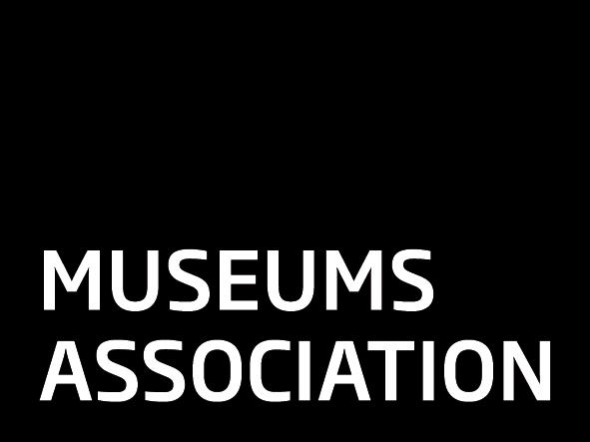Museums Association

CPD Plan

This is my original plan
This is a revised plan
This is my future plan

Covering Period | From | To
Name
Membership Number

Please tick to confirm that:

This plan is current and runs 2 years into the future

This plan has 4 – 5 goals

Your goals reflect how you want to develop as a professional and not your job tasks
Your activities have realistic timescales

Your mentor has sent us an email to confirm they have discussed this CPD plan with you

Please email completed form to cpd@museumsassociation.org

Please Note: Your plan must be accompanied by an email from your mentor stating that they have read and discussed it with you

For more information please contact the Professional Development, Museums Association, 42 Clerkenwell Close, London EC1R 0AZ T: 020 7566 7860
CPD Plan

A – Current role and future aspirations
Summarise the key areas of your current role
*
*
*

State your long-term career aspirations.
*
*
*

B – CPD Goals  Set out the 4 or 5 significant steps you are going to take over the next 2 years that will bring you closer to your career aspirations | C – Development Needs  What specific skills, knowledge and experience do you need to develop in order to achieve each goal? | D - CPD Activities  What are you actually going to do, to fulfil each need? Activities should be SMART

